Data Mining
Muhammad Hassan Khalid
21L-5692
Quiz 1

Dataset is all numeric and many instances of ifferent types of elements total instances 214 and attribyurs10
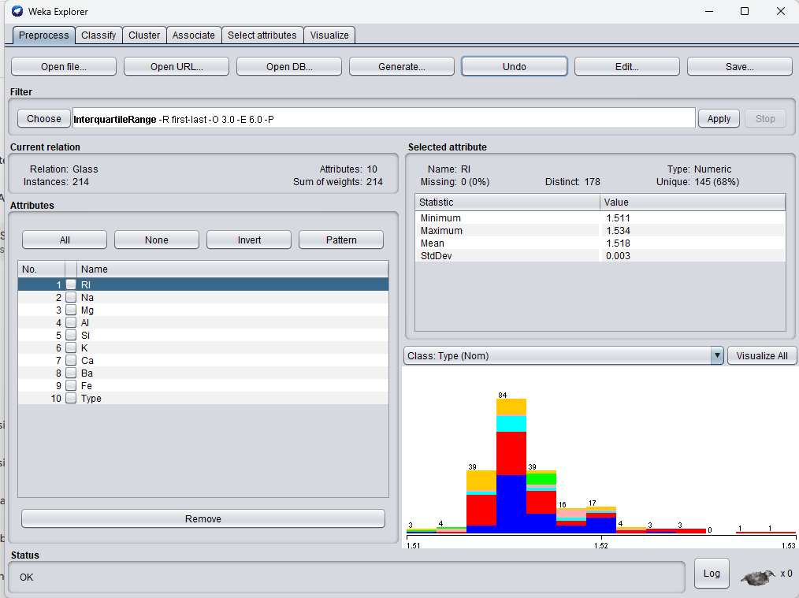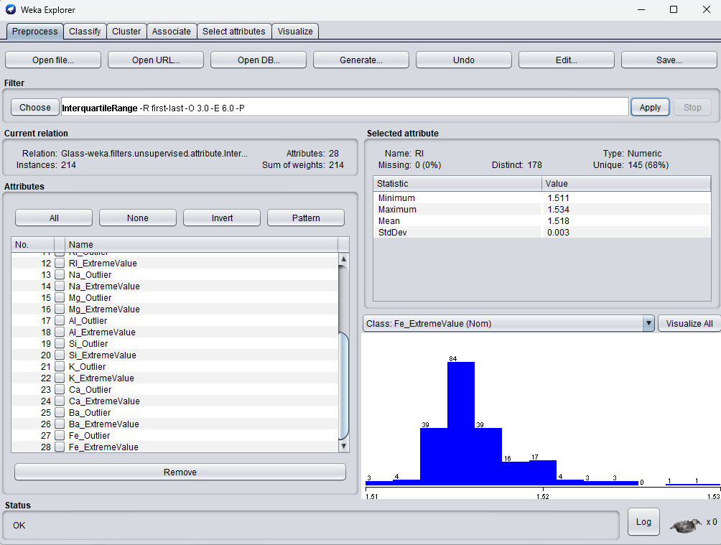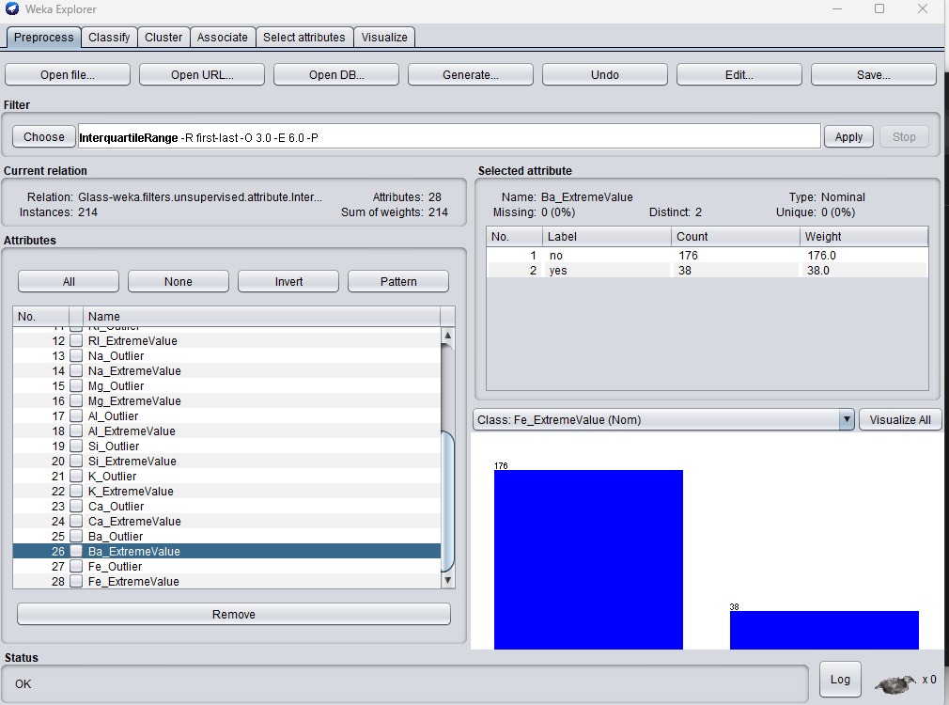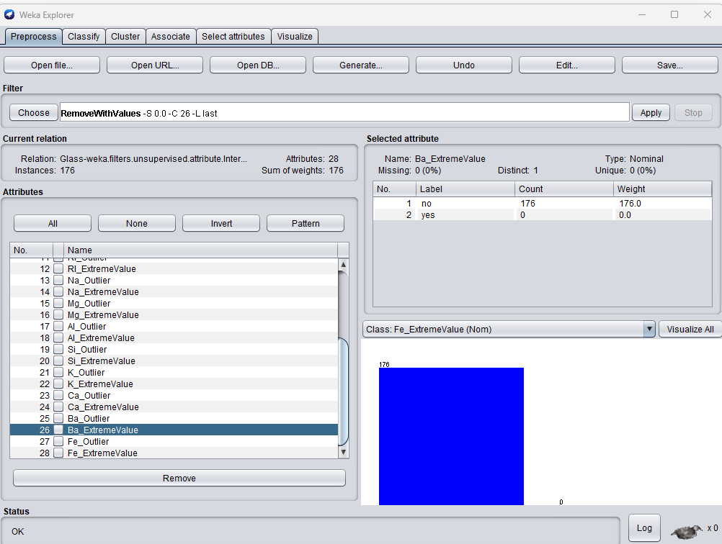
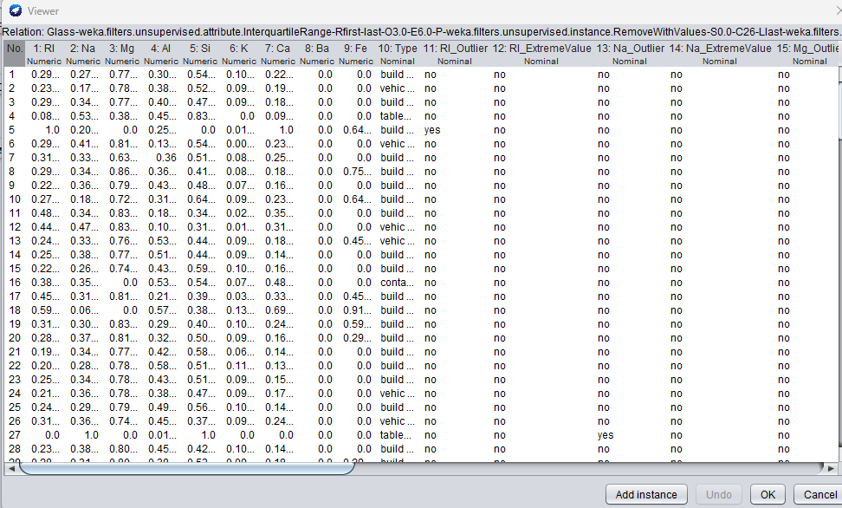

I normalized all the values so that the classifier can better learn also I used interquartile range to find the outliers and then removed them as you can see in the above pictures

C part
Before Preprocessing
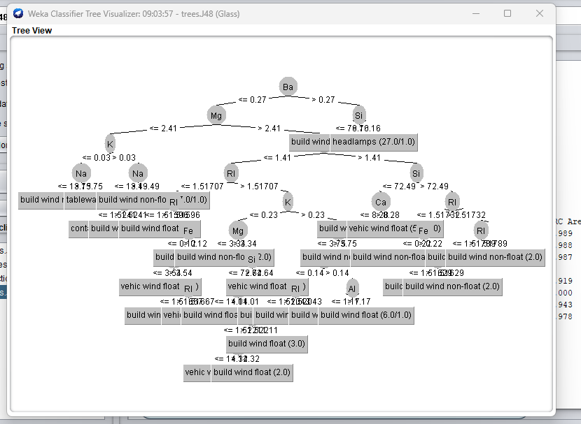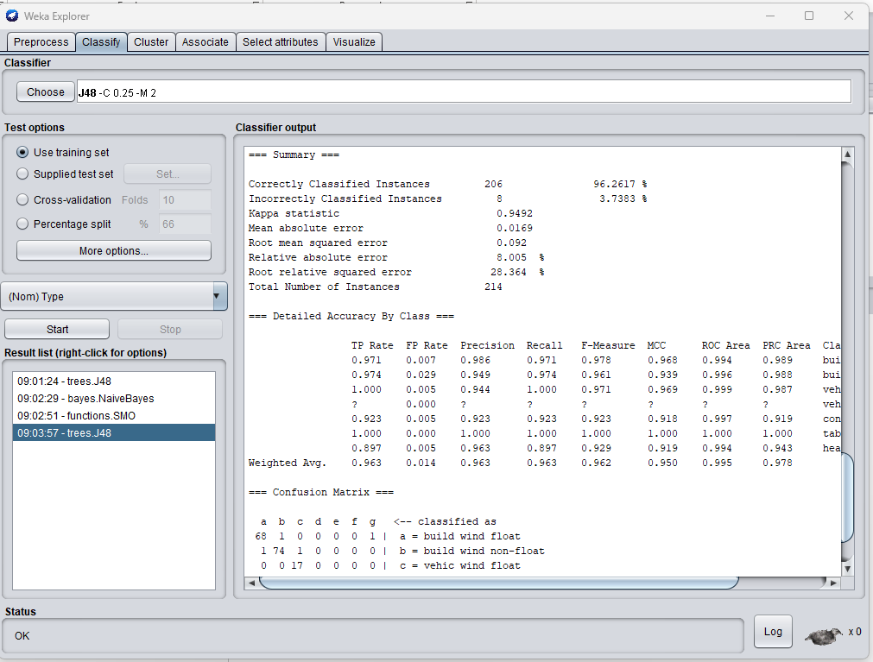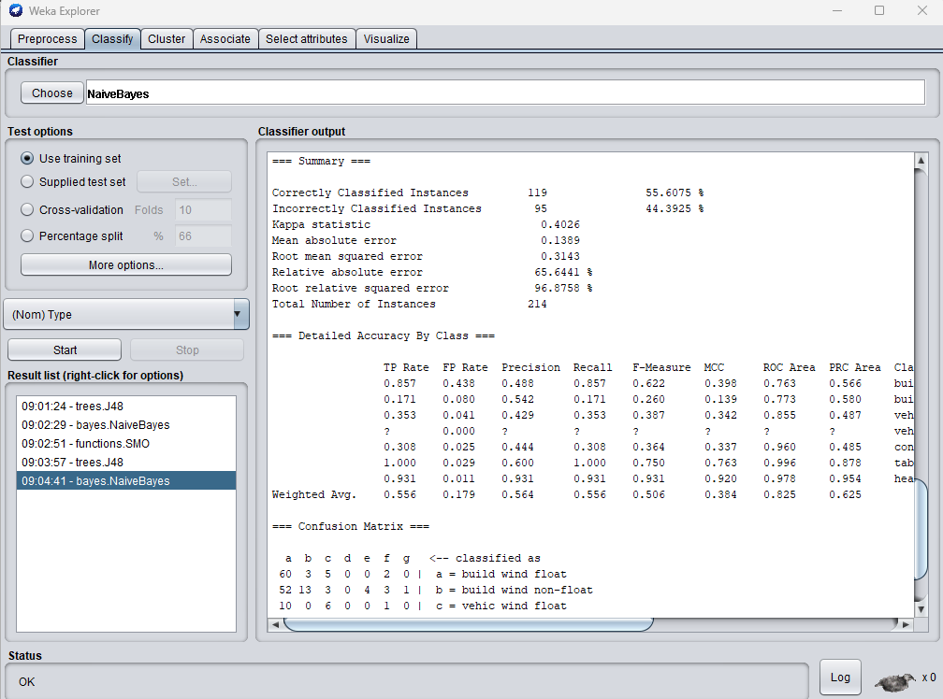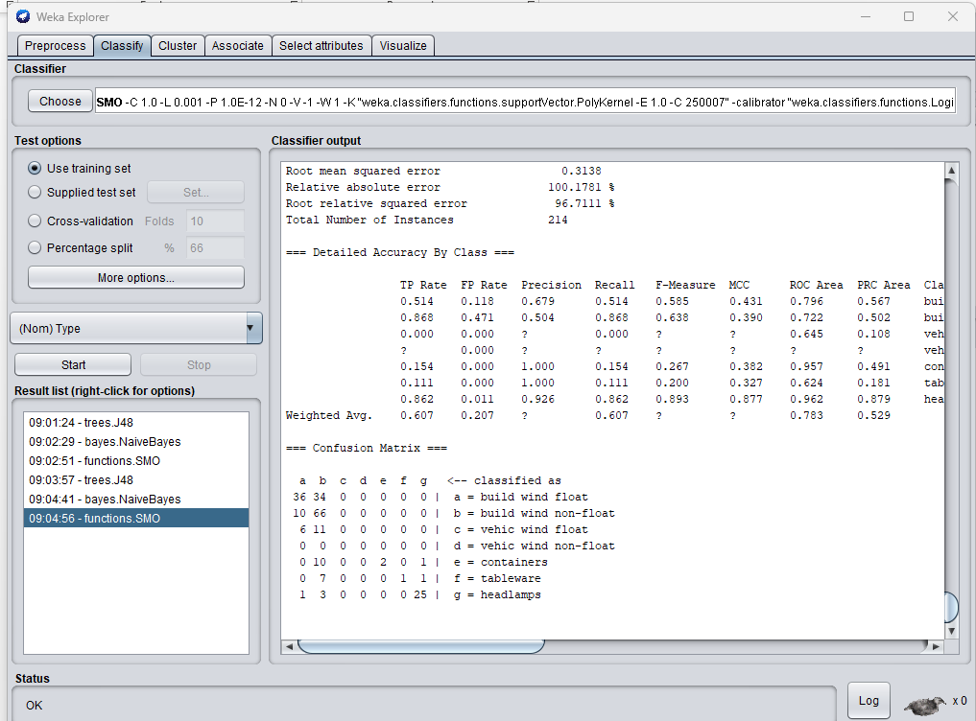

AFTER PREPROCESSING
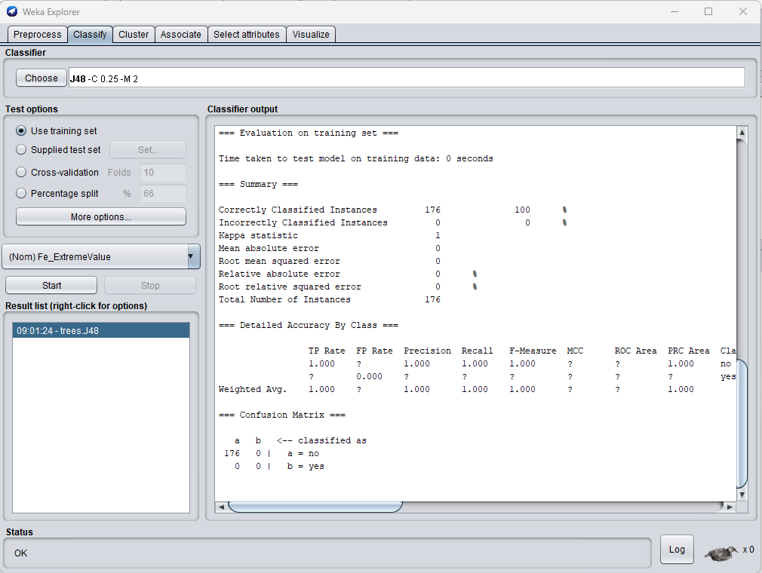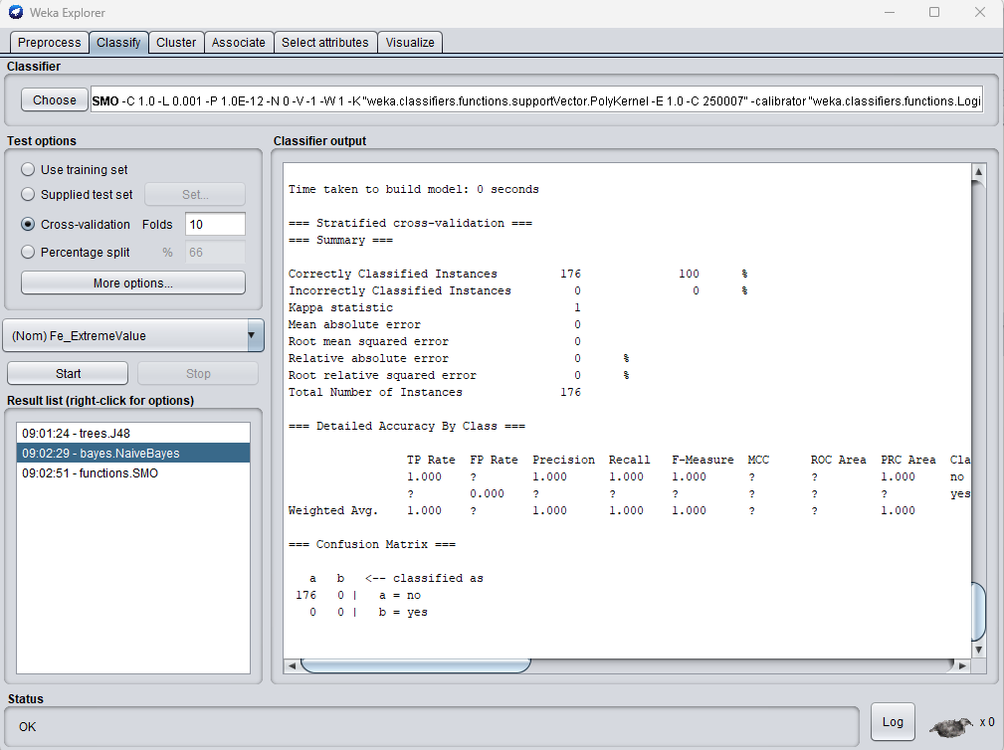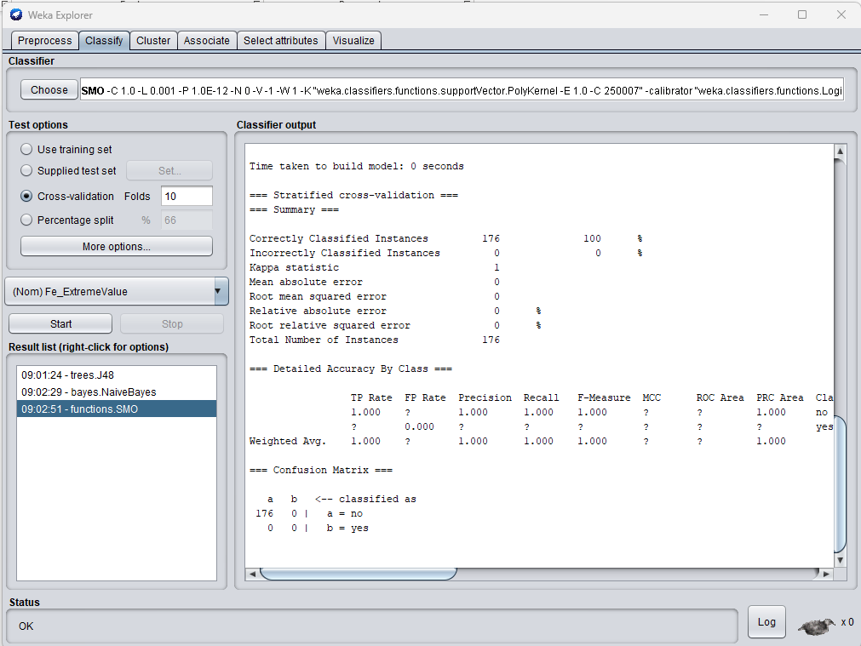

All the three classifiers work well on my dataset after preprocessing and give 100 accurate answers aas you can see from pivtures they can easilyt predict right thing and all work well preprocessing is just required for my dataser

